

**IISC Bengaluru CCE 2022**

**Computing for Artificial Intelligence and Machine Learning**

**Project Report**

**On**

**Credit Decision Model in Lending Industry**

Predict the probability that customer does not pay back balance their credit card/ pay later card/ super card based on demographic & historical credit history data

**Submitted by**

**Mr. Chetan Mehatre**

**Mr. Karan Rajput**

**Industry Overview -**

The global FinTech lending market size was valued at $449.89 billion in 2020 and is projected to reach $4,957.16 billion by 2030, growing at a CAGR of 27.4% from 2021 to 2030. FinTech lender engages in using online technology to provide finance to businesses and individuals. Loans provided by these lenders are generally unsecured and take a personal guarantee from the borrowers. Moreover, it offers short-term loans with a quick turnaround from application to approval of loan amount. Furthermore, the FinTech lending process begins with online application with user registration, online documentation submission, customer authentication & verification, loan approval, loan disbursement, and loan recovery.

It allows borrowers to easily apply for loans and offers them transparency, which, in turn, leads to significant time savings. This automated nature of FinTech lending offers a more precise approach by delivering funding solutions, thus reducing stress and increasing chances of successful loan approval. However, rise in need for digital financing among individuals has led to increase in number of sophisticated cyberthreats where phishing scams, fraudulent behaviors, and malwares are improvising with increasing number of attempts. This is thereby becoming one of the major factors hampering the FinTech lending market growth.

On the contrary, implementation of cloud-based lending solutions enables FinTech firms to integrate supplementary infrastructure technologies with each other to create robust and highly secure platforms. This rising trend of cloud-based services is projected to provide lucrative opportunities for the FinTech lending market in the upcoming years.

Top Indian Companies in market -

* Jupiter Money
* Slice
* Fi Money
* Unicard
* Razorpay
* Navi

Facilities provided -

* Credit Card
* Buy Now Pay Later
* Super Card
* Personal Loans

**Problem Statement:**

* How to check credit worthiness of a customer?
* How much credit limit to be given?
* How to decide the interest rate for a particular customer?

**Data Source -**

American Express is a globally integrated payments company. The largest payment card issuer in the world, they provide customers with access to products, insights, and experiences that enrich lives and build business success.

Credit default prediction is central to managing risk in a consumer lending business. Credit default prediction allows lenders to optimize lending decisions, which leads to a better customer experience and sound business economics. Current models exist to help manage risk. But it's possible to create better models that can outperform those currently in use.

To predict the probability that a customer does not pay back their credit card balance amount in the future based on their monthly customer profile. The target binary variable is calculated by observing 18 months performance window after the latest credit card statement, and if the customer does not pay due amount in 120 days after their latest statement date it is considered a default event.

The dataset contains aggregated profile features for each customer at each statement date. Features are anonymized and normalized, and fall into the following general categories:

* D_* = Delinquency variables
* S_* = Spend variables
* P_* = Payment variables
* B_* = Balance variables
* R_* = Risk variables

Shape of data

Rows - 924621

Columns - 190

Performance window - 18 months

Target variable - 120+ DPD latest statement

**Pre-Processing/Cleaning -**

1. Stratified sample of 10000 data is chosen
2. Checking data info
3. Checking duplicates value
4. Checking Null Values
5. Dropped columns with 80% Null values
6. Filling remaining Null values with appropriate methods

**Block Diagram:**

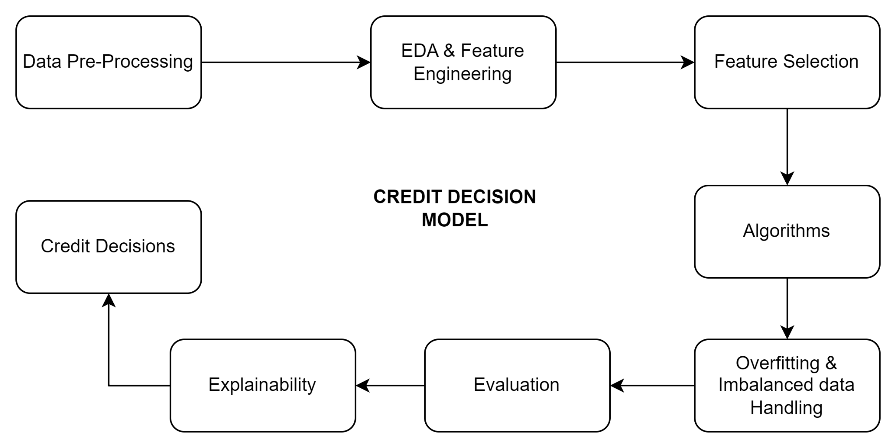

Feature selection is the process of reducing the number of input variables when developing a predictive model.

It is desirable to reduce the number of input variables to both reduce the computational cost of modeling and, in some cases, to improve the performance of the model.

Statistical-based feature selection methods involve evaluating the relationship between each input variable and the target variable using statistics and selecting those input variables that have the strongest relationship with the target variable. These methods can be fast and effective, although the choice of statistical measures depends on the data type of both the input and output variables.

